Notice about Online Supplementary Mid-Term Examination of
Summer Semester, 2021 (Trimester)

The students of all Programs (Day & Evening) of Bangladesh University of Business & Technology (BUBT) and all others concerned are hereby informed that the students who failed to appear at the Online Mid-Term Examination of Summer Semester, 2021 held from 2nd October 10th October, 2021 in any course/courses on unavoidable reasons are advised to apply for Online Supplementary Mid-Term Examination by annex of BUBT website (http://annex.bubt.edu.bd). The students shall have to pay a fee of Tk. 500/- for each course which can be paid by BUBT online payment system or direct in the office of the University.
They are also hereby informed that the last date of reaching their applications to the University is 16th October, 2021.

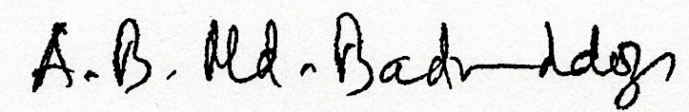

(Prof. A. B. Md. Badruddoza Mia)
Controller of Examinations
N.B. Please contact 01673 462126 for any enquiry.
Distribution:
- P.S to the Vice Chancellor
- P.A to the Pro-Vice Chancellor
- Treasurer
- Dean, Faculty of Arts & Humanities / Business/Engineering & Applied Sciences/ Law
- Registrar
- Chairman, Department of
Marketing/Management/Finance/Economics/English/Accounting/ EEE /CSE / Mathematics & Statistics /Law & Justice /Textile Engg.
- Joint Director, Accounts
- All faculty
- Assistant Registrar, (Admission)
- Notice Boards
- Front Desks
- Website upload (Room No.521)
- Office Copy

